Fossil Impressions: What can a mold or cast of a fossil show you? (Grades 3-5)

Tennessee State Standards Covered
GLE 0307.Inq.1 Explore different scientific phenomena by asking questions, making logical predictions, planning investigations, and recording data
GLE 0307.Inq.2 Select and use appropriate tools and simple equipment to conduct an investigation
GLE 0307.Inq.3 Organize data into appropriate tables, graphs, drawings, or diagrams
GLE 0307.Inq.5 Recognize that people may interpret the same results in different ways
GLE 0307.Inq.6 Compare the results of an investigation with what scientists already accept about this question
0507.5.3 Identify the processes associated with fossil formation
*Embedded Inquiry is identical for Grades 3-5.

Summary
Students make molds and casts of objects to make their own fossils.

Objective
Students will be able to:
- Describe how a fossil forms
- Create a model of a fossil mold and cast

Skills Summary
- Creating
- Understanding

National Science Education Standards
- (K-4) Standard D-1: Properties of earth materials

Time
- Approximately 30 minutes
Materials
- A small, solid object such as a shell, coin, key
- Clear cups or bowls
- Modeling clay
- Plaster of Paris
- Stir sticks
- Vegetable oil
- Water
- Images: a fossil forms; making a mold and cast

Vocabulary
- Cast: Impression formed when a liquid substance is poured into a form of mold, and then hardens into that shape
- Fossil: Remnant, impression, or trace of an ancient organism
- Mold: Hollow structure used to give form to a liquid substance as it hardens

Background
Scientists sometimes find casts of fossils. Casts are copies of the original object.

Procedures

- Display the illustrations to show students one way a fossil forms.
- Scroll through the color illustrations and read aloud each caption to help students understand how a fossil forms. Explain to students that fossils form in many ways. Sometimes a leaf, shell, or foot leaves an imprint in soft earth. When the imprint hardens, it forms a mold. Later, mud or other materials can fill the mold to make a cast—a copy of the original. Have students look at the black-and-white illustration of what a mold and cast look like. Tell them they will make a mold and a cast of an object during this activity.
- Have students choose an object and make a mold.
- Before making the mold, draw a predictive sketch of how you think it will look.
- Provide students with some clay. Have each student shape the clay into a small circle slightly bigger than the object they selected. Have them place the circle on a flat, dry surface and make a rim around the top edge.
- Have students use their selected object to make an imprint.
- Have students smooth a small amount of vegetable oil on the object so it will not stick to the clay. Then ask them to carefully push the object into the clay and then remove it. Provide assistance, as needed. The imprint left behind will create a mold.
- Help students make a cast.
- Follow the mixing directions on the Plaster of Paris package. Quickly pour the mixture on students' clay models. Fill the mold to the rim. Tap and shake it to remove air bubbles.
- Have students compare their casts to the original objects.
- Allow the cast to dry for 30 minutes or more until it is cool and hard. Help students to carefully separate the cast from the mold. Then have a whole-class discussion. Ask: How does it compare to the original object?
- How does the cast and imprint reflect your original sketch of what the fossils would look like?
6. Have students compare with their neighbor?
- How are your molds similar and different?

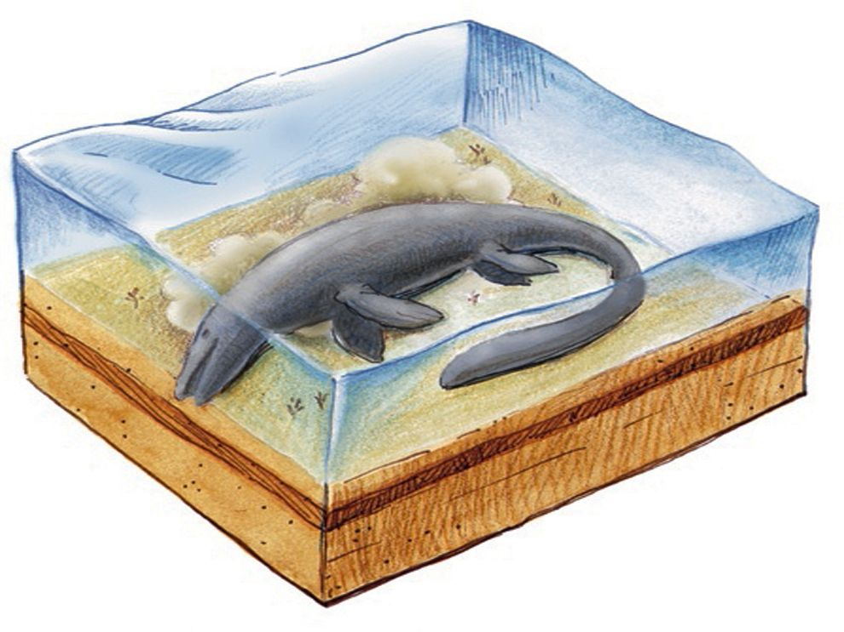 | 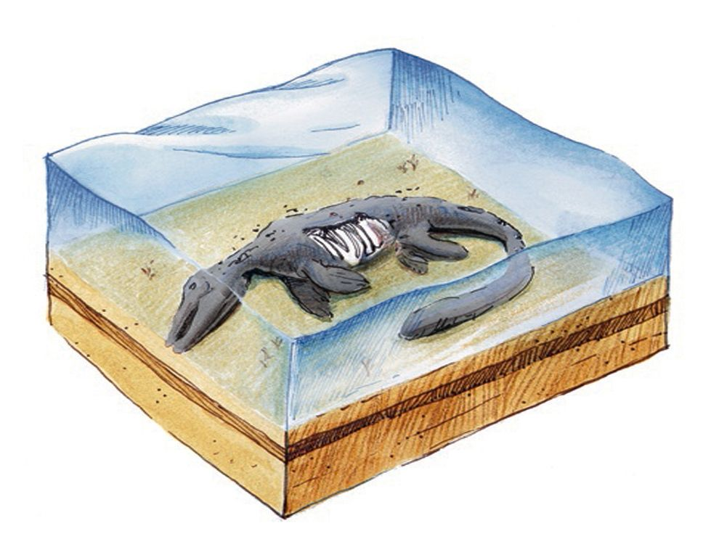
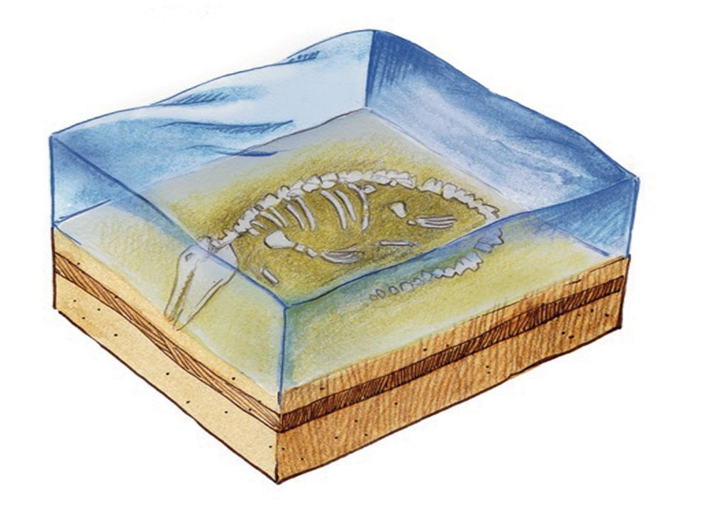 | 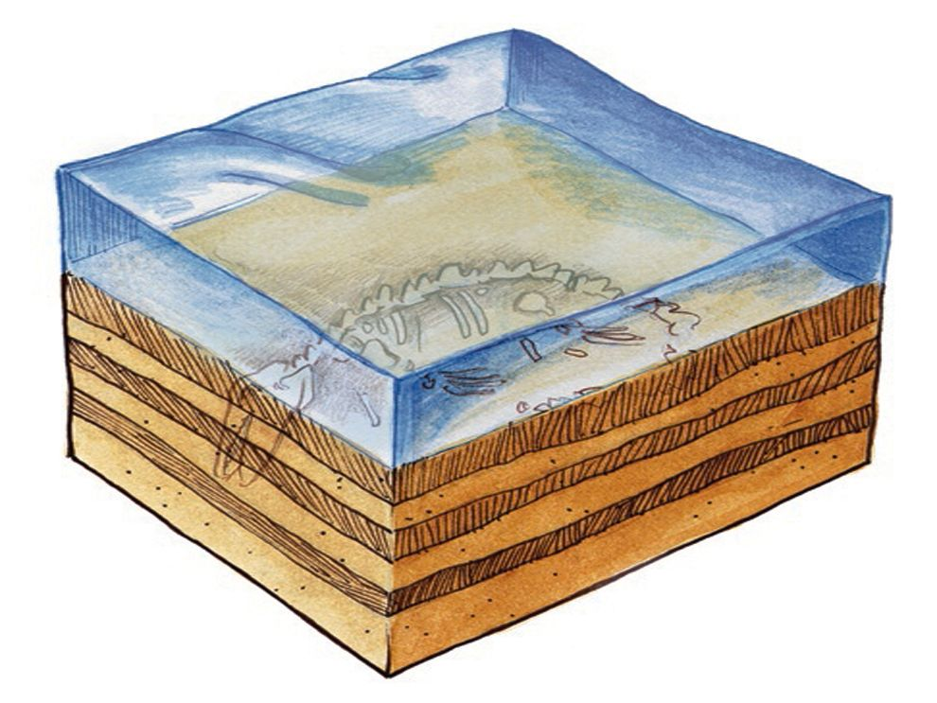
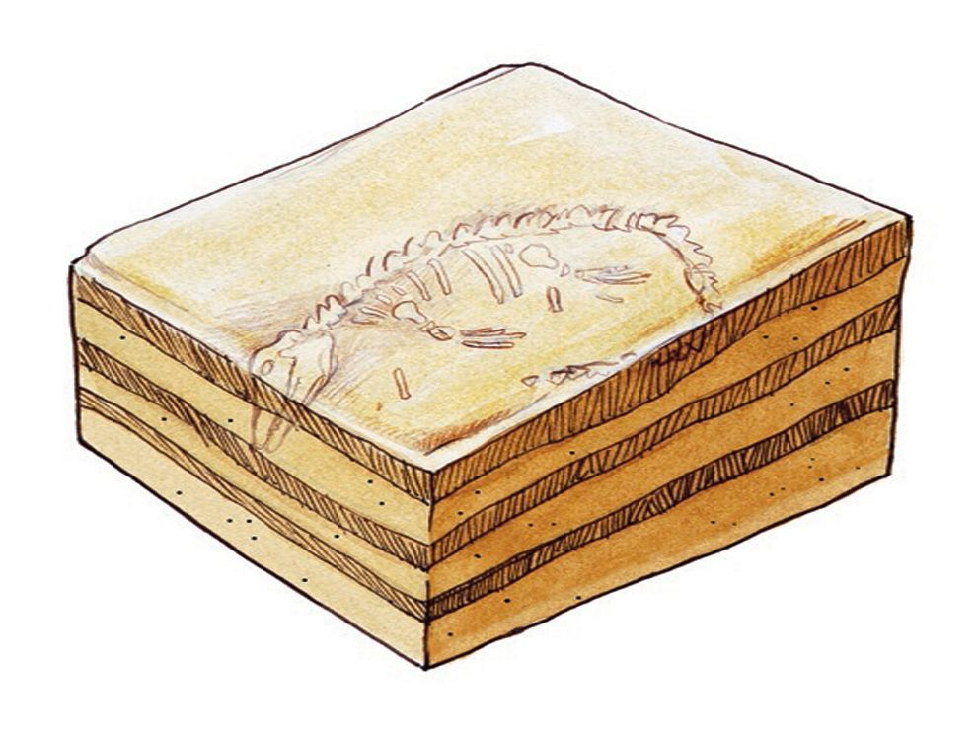 | 